**The Effect of β-Hydroxybutyrate on the PI3K/Akt/mTOR Pathway in Mouse Glioma Cells**

Lucas H. Prescott1,Meghan R. Grewal1

Eric C. Woolf 1,2, Adrienne C. Scheck1, 2

1 Neuro-Oncology Research, Barrow Neurological Institute, Phoenix, AZ; 2 School of Life Sciences, Arizona State University, Tempe, AZ

**Abstract**

The ketogenic diet (KD) has been used to control refractory epilepsy and has recently shown potential as an adjuvant therapy for glioblastoma multiforme (GBM), although its mechanisms are still to be understood. Here we examine how beta-hydroxybutyrate (BHB), one of the main ketones increased *in vivo* by the KD, affects some of the central factors in the PI3K/Akt/mTOR pathway, an important pathway in cancer initiation and progression that controls protein synthesis, autophagy, cytoskeletal organization, lipid metabolism, mitochondrial biogenesis and metabolism, and likely much more. To assess these changes, we performed western blot analysis on mouse malignant glioma cells treated with different concentrations of BHB. In particular, we studied the changes in total expression and specific phosphorylation of phosphoinositide 3-kinase (PI3K), Akt (known as protein kinase B, PKB), tuberous sclerosis complex 2 (TSC2), mechanistic target of rapamycin (mTOR), proline-rich Akt substrate of 40 kDa (PRAS40), 14-3-3ε, and p70 ribosomal protein S6 kinase (p70 S6K). Understanding how BHB alters expression and activation of these proteins may help us better understand how the KD affects more than just basic metabolic pathways to have an overall beneficial impact on treatment of GBMs in humans.

**Background**

Almost 10,000 cases of glioblastoma multiforme, the most aggressive type of brain cancer, are diagnosed in the U.S. annually. Median survival with current treatments is about 14.6 months, and less than 10% survive 3 years [1]. These tumors are highly invasive, difficult to totally remove surgically and can adapt to first-line chemotherapy and radiation treatments, often allowing them to recur after treatment. The high-fat, low-carbohydrate, adequate-protein KD has long been known to benefit patients with epilepsy and has recently shown promise as an effective adjuvant therapy for GBM as well as many neuromuscular and neurodegenerative disorders [2, 3]. As the body breaks down fats, ketones capable of penetrating the blood-brain barrier (BBB) [4] are produced and affect many cellular pathways that can slow tumor proliferation. Our investigation focuses on the effects of elevated BHB in the absence of glucose reduction. Future studies will include both elevated BHB and reduced glucose. Much work has been done *in vivo* to show the benefits of the KD, yet the mechanisms through which BHB and the KD operate are still not fully understood.

**Methods**

GL261-luc2 cells mock-treated or treated with 2mM, 5mM, and 10mM BHB for 24 hours. Protein was isolated using RIPA buffer (Cell Signaling Technology, Danvers, MA (CST)) with 1mM phenylmethylsulfonyl fluoride (PMSF) (Sigma-Aldrich, St. Louis, MO). The concentration of protein in each sample was determined using the Pierce BCA Assay protein assay kit (Thermo Scientific, Rockford, IL). Protein was loaded onto precast Bolt™ 4-12% Bis-Tris Plus gels (Invitrogen, Carlsbad, CA), separated by electrophoresis, and transferred to nitrocellulose membranes. Membranes were incubated in primary antibody, 1X TBS, 0.1% Tween® 20 (Sigma-Aldrich), and 5% w/v BSA (Santa Cruz Biotechnology, Dallas, TX (SCB)) overnight at 4°C. The primary antibodies used are as follows:

|  |  |  |  |
| --- | --- | --- | --- |
| **Antibody** | **Host** | **Dilution** | **Source** |
| β-Actin | Mouse mAb | 1:2000 | LI-COR, Lincoln, NE |
| Akt1 (C73H10) | Rabbit mAb | 1:1000 | CST |
| Akt2 (D6G4) XP(TM) | Rabbit mAb | 1:1000 | CST |
| Akt3 | Rabbit mAb | 1:1000 | CST |
| Phospho-Akt (Ser473) (D9E) XP(R) | Rabbit mAb | 1:1000 | CST |
| Phospho-PI 3 Kinase p110 delta (Tyr524) | Rabbit pAb | 1:200 | Bioss, Boston, MA |
| Phospho-Tuberin/TSC2 (Thr1462) (5B12) | Rabbit mAb | 1:500 | CST |
| Phospho-mTOR (Ser2448) (D9C2) XP | Rabbit mAb | 1:1000 | CST |
| Phospho-PRAS40 (T246) (D4D2) XP(R) | Rabbit mAb | 1:1000 | CST |
| Phospho-p70 S6 Kinase (Thr421/Ser424) | Rabbit pAb | 1:1000 | CST |
| 14-3-3 epsilon (T-16) | Rabbit pAb | 1:200 | SCB |
| 14-3-3 epsilon (C-terminus) | Rabbit pAb | 1:3000 | Biomol, Hamburg, Germany |

The membranes were incubated in Goat anti-rabbit IgG IRdye® 800CW (1:15000, LI-COR), and goat anti-mouse IgG IRdye® 680RD (1:15000, LI-COR) secondary antibodies for an hour at room temperature. The fluorescence of the target proteins was analyzed with LI-COR Odyssey® Fc and analyzed with Image Studio Lite Version 5.2 (LI-COR) and normalized to β-actin. Unpaired, two-tail, student’s t-tests were performed to determine statistical significance in the data. Graphs were generated using GraphPad Prism 5 (GraphPad Software, Inc., San Diego, CA).

**The PI3K/Akt/mTOR Pathway**

The PI3K/Akt/mTOR signaling pathway regulates many factors in the cell cycle and therefore cell growth and proliferation. Glioma cells often hyperactivate these proteins so that they can move through the cell cycle more quickly [5]. Many specific inhibitors of proteins in this pathway are being developed to treat cancers, but the complexity of the pathway’s interactions can make the deactivation of what appears to be an oncoprotein actually hyperactivate the rest of the pathway via crosstalk and feedback loops [6]. For example, inhibition of mTOR by rapamycin causes Akt phosphorylation/activation via S6K’s insulin-resistance-inducing effect on insulin receptor (IR) [7, 8]. The downregulation of key components in the PI3K/Akt/mTOR pathway shown here help to explain how BHB (and therefore likely the KD) can slow tumor progression and benefit patients with GBM.

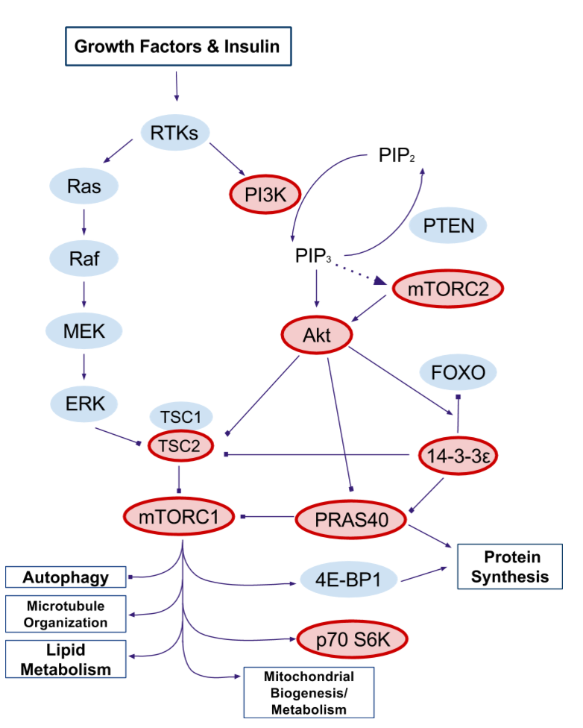

**Figure 1. Simplified diagram of the PI3K/Akt/mTOR pathway.** The thick border denotes proteins that we have tested as part of this experiment. No border denotes proteins of interest that have yet to be tested.

**Abbreviations:** 4E-BP1, eukaryotic initiation factor 4E-binding protein 1; Akt, protein kinase B; ERK, extracellular signal-related kinase; FOXO, forkhead box O; MEK, mitogen-activated kinase kinase; mTORC1, mechanistic target of rapamycin complex 1; mTORC2, mechanistic target of rapamycin complex 2; PI3K, phosphoinositide 3-kinase; PIP2, phosphatidylinositol (4,5)-bisphosphate; PIP3, phosphatidylinositol (3,4,5)-trisphosphate; PRAS40, proline-rich Akt substrate; PTEN, phosphatase and tensin homolog; Raf, rapidly accelerated fibrosarcoma; Ras, rat sarcoma GTPase; RTKs, receptor tyrosine kinases; p70 S6K, p70 ribosomal protein S6 kinase beta-1; TSC1, tuberous sclerosis 1; TSC2, tuberous sclerosis 2.

**Hypothesis**

BHB treatment will reduce expression and activation of multiple central control points in growth signaling pathways, including PI3K, Akt, and mTOR. This helps to explain the mechanisms behind the slowed proliferation of glioma cells *in vitro* and potentially of GBMs *in vivo*.

**Results**

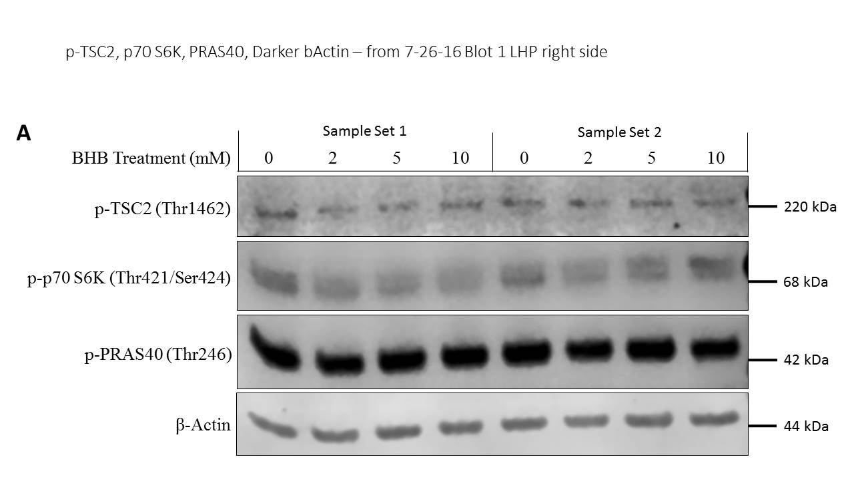

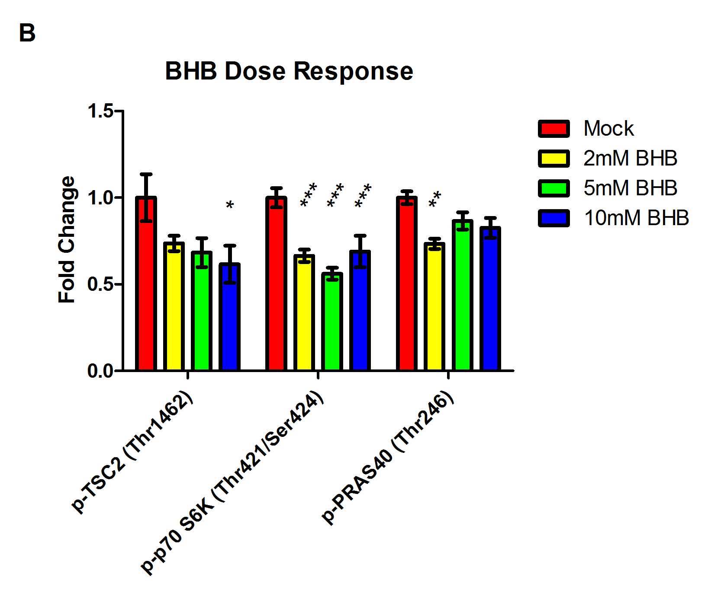

**Figure 2. Western blot analysis of PI3K/Akt/mTOR-related proteins.** (A) Western blot showing p-TSC2 (Thr1462), p-p70 S6K (Thr421/ Ser424), p-PRAS40 (Thr246) expression in GL261-luc2 cell line. (B) Expression was quantified, normalized to β-actin and represented as a fold change relative to mock treated cells (*p < 0.05, **p < .01, ***p < .001).

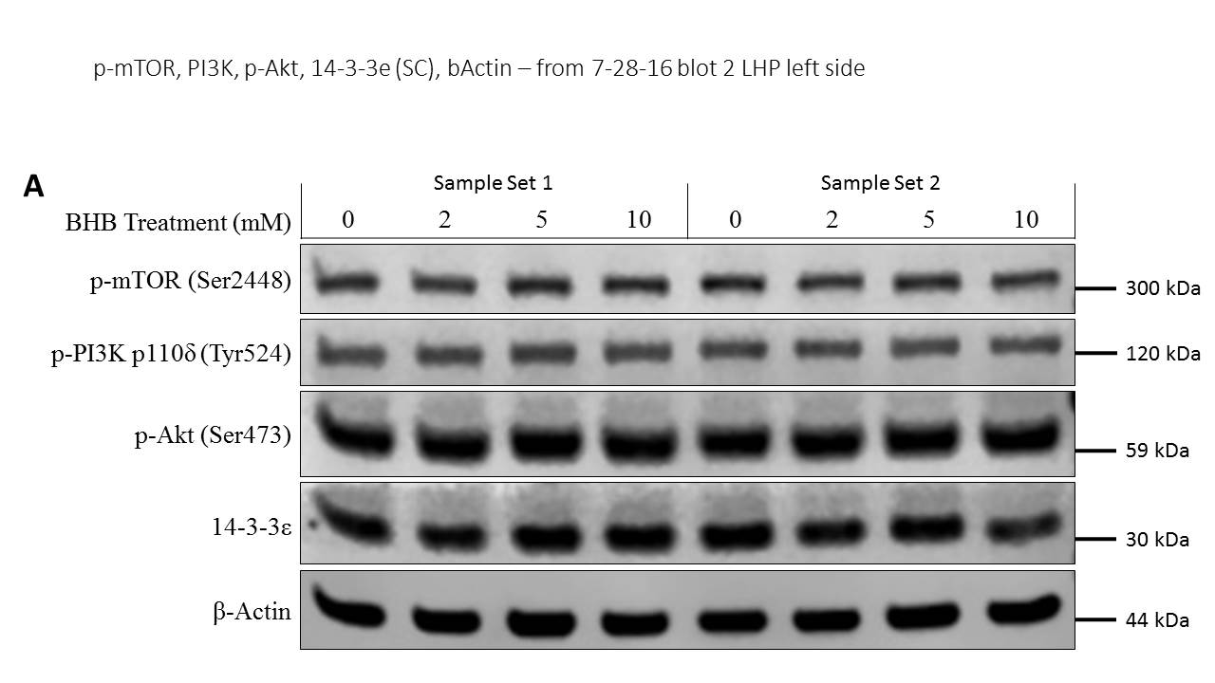

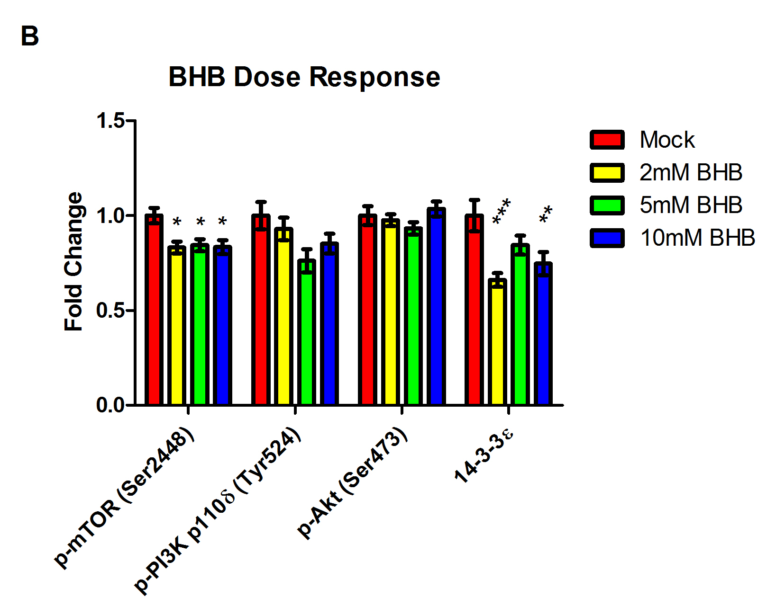

**Figure 3. Western blot analysis of PI3K/Akt/mTOR-related proteins.** (A) Western blot showing p-mTOR (Ser2448), p-PI3K p110𝛿 (Tyr524), p-Akt (Ser473), 14-3-3ε expression in GL261-luc2 cell line. (B) Expression was quantified, normalized to β-actin and represented as a fold change from mock (*p < 0.05, **p < .01, ***p < .001).

**Future Studies**

* Additional western blots will be performed on cells treated with and without BHB to determine the effect of ketones on expression and activation of MAPK-associated proteins (Ras, MEKs, and ERKs, related transcription factors (FoxO1 and STAT3), 4E-BP1 (another downstream target of mTORC1), and on different phosphorylation sites of the proteins examined in this study.
* Western blots will be performed on cells treated with BHB for different durations to see how quickly ketones can change expression and activation of these proteins.
* Native western blots will be performed to determine the effect of ketones on specific proteins as complete complexes. mTOR is a component of two complexes (mTORC1 and 2) that function and are activated independently of each other. Examining their changes would elucidate the pathway’s alterations more than measuring overall mTOR concentrations.
* Western blots will be performed on samples isolated at different time points after cycloheximide treatment to determine the effect of ketones on the rates of specific protein degradation.
* PCR will be performed to determine how ketones affect the transcription of relevant genes. Both pre- and post-transcriptional regulation can alter final protein concentrations examined via western blot analysis, so pinpointing when the BHB-induced changes occur via PCR is necessary to fully understand how the KD alters these pathways.

**Acknowledgements**



**Works Cited**

1. Anton K, Baehring JM, Mayer T. Glioblastoma Multiforme: Overview of Current Treatment and Future Perspectives (2012). *Hematol Oncol Clin N Am*, 26, 825-853. Doi:10.1016/j.hoc.2012.04.006.
2. Paoli A, Bianco A, Damiani E, Bosco G. Ketogenic Diet in Neuromuscular and Neurodegenerative Diseases (2014). *BioMed Research International*, Article ID 474296, 10 pages.
3. Woolf EC, Curley KL, Liu Q, Turner GH, Charlton JA, Preul MC, Scheck AC. The Ketogenic Diet Alters the Hypoxic Response and Affects Expression of Proteins Associated with Angiogenesis, Invasive Potential, and Vascular Permeability in a Mouse Glioma Model (2015). *PLoS ONE* 10(6): e0130357. doi:10.1371/journal.pone.0130357.
4. Hasselbalch SG, Knudsen GM, Jakobsen J, Hageman LP, Holm S, Paulson OB. Blood-brain barrier permeability of glucose and ketone bodies during short-term starvation in humans (1995, Jun). *Am J Physiol*, 268(6 Pt 1):E1161-6.
5. Akhavan D, Mischel, PS. MTOR Signaling in Glioblastoma: Lessons Learned from Bench to Bedside (2009). *MTOR Pathway and MTOR Inhibitors in Cancer Therapy,* 99-111. doi:10.1007/978-1-60327-271-1_5.
6. Carracedo A, Pandolfi PP. The PTEN-PI3K pathway: of feedbacks and cross-talks (2008). *Oncogene*, 27, 5527-5541. doi:10.1038/onc.2008.247.
7. Manning BD. Balancing Akt with S6K: implications for both metabolic diseases and tumorigenesis (2004). *J Cell Biol The Journal of Cell Biology,* *167*(3), 399-403. doi:10.1083/jcb.200408161.
8. Sully K, Akinduro O, Philpott MP, Naeem AS, Harwood CA, Reeve VE, O’Shaughness RF, Byrne C. The mTOR inhibitor rapamycin opposes carcinogenic changes to epidermal Akt1/PKBα isoform signaling (2013, Jul 4). *Oncogene,* *32*(27), 3254-3262. doi:10.1038/onc.2012.338.